QParents    qparents.qld.edu.au | QParents provides parents with 24/7 online access to:  - Receiving and paying invoices  - Viewing attendance records and providing absentee notifications.  - Academic reporting data.  - Limited behaviour records.  The school will need to send you a QParents invitation email to start the registration process.
QKR   | The QKR app is the preferred ordering system for tuckshop and uniform sales.  1st break tuckshop orders must be placed by 9:00am.  2nd break tuckshop orders must be placed by 12:00pm.  Uniforms ordered through the app will be processed and given to the student.  If you are experiencing difficulties using the app, QKR have advised you can use the website portal on your computer (qkr-store.qkrschool.com)
Bpoint   | Bpoint is the preferred method of paying school invoices.  The internet web link (located at the bottom of your invoice) will allow you to pay school invoices securely from your own computer.  You will need the Customer Reference Number (CRN) printed at the bottom of your invoice.  It is important that if you have multiple invoices to pay, that you pay them separately using each individual invoice’s CRN.
Email Address   | Please send all student correspondence to admin@emuparkss.eq.edu.au
Absences  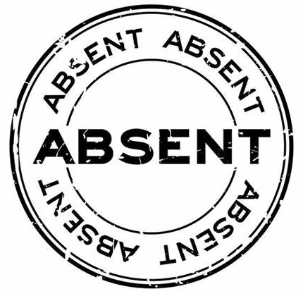 | If you child is going to be absent from school, please notify us by either;  - SMS (0426 305 042)  - QParents  - Phoning and leaving a message on the absence line  - Emailing – admin@emuparkss.eq.edu.au  Please advise the student’s name, date absent and reason.  SMS notifications are sent each morning if your child is absent from school and we have not been advised of the reason.
Late Sign In / Early Sign Out   | The roll is marked at 9:00am. If your child arrives at school after this time, they will need to present to the office to sign in and receive a late slip to take to the class teacher.  If you need to collect your child early for an appointment, please come to the office to sign them out. To avoid missing out on valuable learning time, student’s will not be called from class until there is someone in the office ready to collect them.
Illness   | If your child shows signs of illness before leaving for school, they should be kept at home.  Students that fall sick at school are cared for in the health room. School staff will contact parents if the situation warrants or there is no improvement.
Medication   | Medication is administered by staff, provided it is strictly in accordance with instructions from the student’s doctor and is requested by the parent on the appropriate medication form. The medication form is available from the school website and the school office.  We are unable to administer any form of medication (including over the counter medications such as Panadol, antihistamines etc) unless it is in the original container with the dosage stated by a doctor (either by script, letter, or a form which is also available from the office.  Asthma and Anaphylaxis – an Individual Action Plan, signed by a medical practitioner must be provided to the office.
Mobile Phones  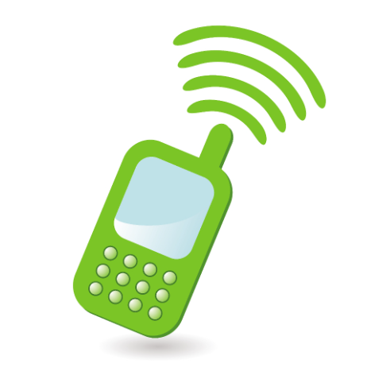 | All Qld state school students must keep their mobile phone ‘away for the day’ during school hours. Notifications on wearable devices, such as smartwatches, must be switched off so that phone calls, messages and other notifications cannot be sent or received during school hours.  At Emu Park SS, students are required to hand their phone into the office each morning where it will be stored securely until after the 3pm bell. Please email admin@emuparkss.eq.edu.au to request Principal approval for your student to bring their phone to school.
School Website   | Essential school information can be found at the school website https://emuparkss.eq.edu.au/
Facebook   | Emu Park State School Facebook page can be found at https://www.facebook.com/groups/1548799441796889

